**Graph Algorithms Visualization using Netwrokx and Tkinter**

Member:

**Salman Ahmed Khan (19K-1043)**

**Abdullah Tilal Khan (19K-1103)**

TO:

**Sir M. Waqas Sheikh**

**Design And Analysis of Algorithm**

Dated: December 10, 2021

**Abstract**

Algorithm visualization aims to facilitate the understanding of algorithms by implementing graphical user interface and animation to verify the execution of algorithms on selected input data file.

The purpose of this project was to analyze the computation of graph algorithms. The graph algorithms were created and visualized as per the algorithms. The graphs algorithms included were minimum spanning, shortest-path, all pair shortest path and the computation of clustering coefficient on various benchmark files which include nodes ranging ten to hundred. The project is implemented on NetworkX Python and Tkinter GUI Python.

**Introduction**

The algorithms that were animated and visualized include graph algorithms. The following algorithm were used:

* Prims Algorithm
* Kruskal Algorithm
* Dijkstra Algorithm
* Bellman Ford Algorithm
* Floyd Warshall Algorithm
* Boruvka Algorithm
* Clustering Coefficient

The benchmark file included input data upon which the algorithms were computed and visualized. The selection of the file and algorithms were required to the system to compute the graph on the basis of algorithm.

**System and Setup**

The purposed system is implemented in NetworkX Python library which created the graph including the nodes and edges. MatplotLib object encapsulate the networkx graph to create the animated graph.

The Tkinter Python Library was implemented to construct the graphical user interface through which user selects the desired benchmark file and algorithm to compute visualization.

Tkinter GUI

Matplot Lib

Networkx Graph

**Result**

The following results were obtained by computation of graph algorithms on some benchmark files:

**Benchmark 1 (10 Nodes):**

Prims: 24.450000000000003

Kruskal: 24.450000000000003

Dijkstra: 29.700000000000003

Bellman Ford: 29.700000000000003

Floyd Warshall: 156.60000000000002

Boruvka: 24.450000000000003

Clustering Coefficient Avg: 0.6583333333333333

**Benchmark 2 (20 Nodes):**

Prims: 51.449999999999996

Kruskal: 51.449999999999996

Dijkstra: 60.900000000000006

Bellman Ford: 60.900000000000006

Floyd Warshall: 247.9500000000001

Boruvka: 51.449999999999996

Clustering Coefficient Avg: 0.48284685086155665

**Benchmark 3 (30 Nodes):**

Prims: 87.60000000000002

Kruskal: 87.60000000000002

Dijkstra: 102.3

Bellman Ford: 102.3

Floyd Warshall: 517.6499999999995

Boruvka: 87.60000000000002

Clustering Coefficient Avg: 0.6980946493593552

**Benchmark 4 (40 Nodes):**

Prims: 137.10000000000002

Kruskal: 137.10000000000002

Dijkstra: 156.14999999999995

Bellman Ford: 156.14999999999995

Floyd Warshall: 643.5

Boruvka: 137.10000000000002

Clustering Coefficient Avg: 0.7709709665090257

**Benchmark 5 (50 Nodes):**

Prims: 131.85

Kruskal: 131.85

Dijkstra: 142.34999999999997

Bellman Ford: 142.34999999999997

Floyd Warshall: 992.25

Boruvka: 131.85

Clustering Coefficient Avg: 0.6114072786596008

**Benchmark 6 (60 Nodes):**

Prims: 199.50000000000009

Kruskal: 199.50000000000009

Dijkstra: 214.95000000000005

Bellman Ford: 214.95000000000005

Floyd Warshall: 354.0

Boruvka: 199.50000000000009

Clustering Coefficient Avg: 0.7103363831898404

**Benchmark 7 (70 Nodes):**

Prims: 195.74999999999997

Kruskal: 195.74999999999997

Dijkstra: 234.14999999999995

Bellman Ford: 234.14999999999995

Floyd Warshall: 631.3499999999992

Boruvka: 195.74999999999997

Clustering Coefficient Avg: 0.685452232971337

**Benchmark 8 (80 Nodes):**

Prims: 249.29999999999995

Kruskal: 249.29999999999995

Dijkstra: 260.24999999999994

Bellman Ford: 260.24999999999994

Floyd Warshall: 631.3499999999992

Boruvka: 249.29999999999995

Clustering Coefficient Avg: 0.7008658687965761

**Benchmark 9 (90 Nodes):**

Prims: 287.1000000000001

Kruskal: 287.1000000000001

Dijkstra: 343.3500000000001

Bellman Ford: 343.3500000000001

Floyd Warshall: 1455.1499999999987

Boruvka: 287.1000000000001

Clustering Coefficient Avg: 0.7858374185184406

**Benchmark 10 (100 Nodes):**

Prims: 304.50000000000006

Kruskal: 304.50000000000006

Dijkstra: 363.0

Bellman Ford: 363.0

Floyd Warshall: 1291.9500000000012

Boruvka: 304.50000000000006

Clustering Coefficient Avg: 0.699423195351583

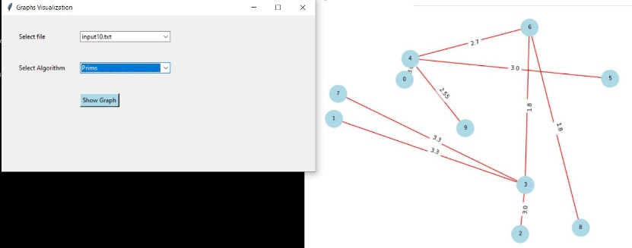 Prims (10Nodes)

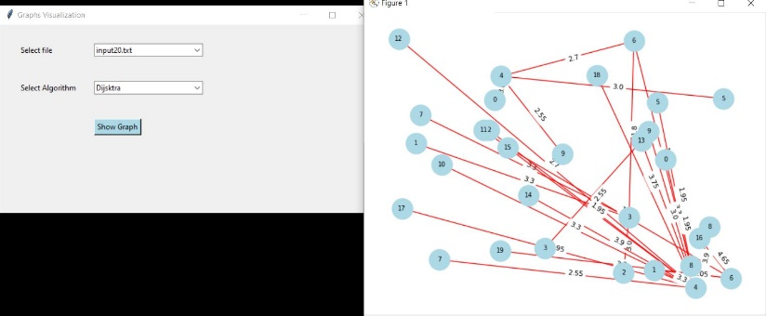Dijkstra (20Nodes)

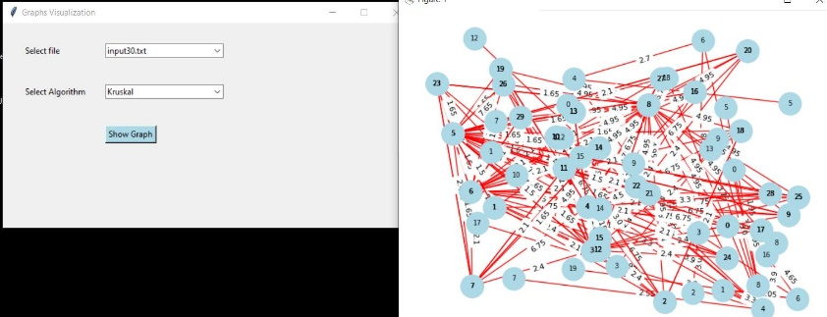Kruskal (30Nodes)

**Conclusion**

The visualization of graphs with various algorithms computed determine the cost required and provide the efficient way to determine the graphs with visualize.